作业提交：仅提交本文件中蓝色标识部分，其余部分请删除。

Laboratory Two – Decoding Lab (Part 1)

Objectives:

For this exercise, you have to compile a program as attached and supply four secret keys to determine the contents. In this laboratory, you have to supply the first two. The remaining will be done next week. I will guide you to solve the problem. This exercise is extracted from the CTE, SSD6 – Exercise one.

The details are as follows.

Start the program:

- invoke the visual C++ and use new to start the workplace.
- Select the New Menu and click “workplace”. The name is called exercise 1
- The project is exercise 1: Select Win32 Console
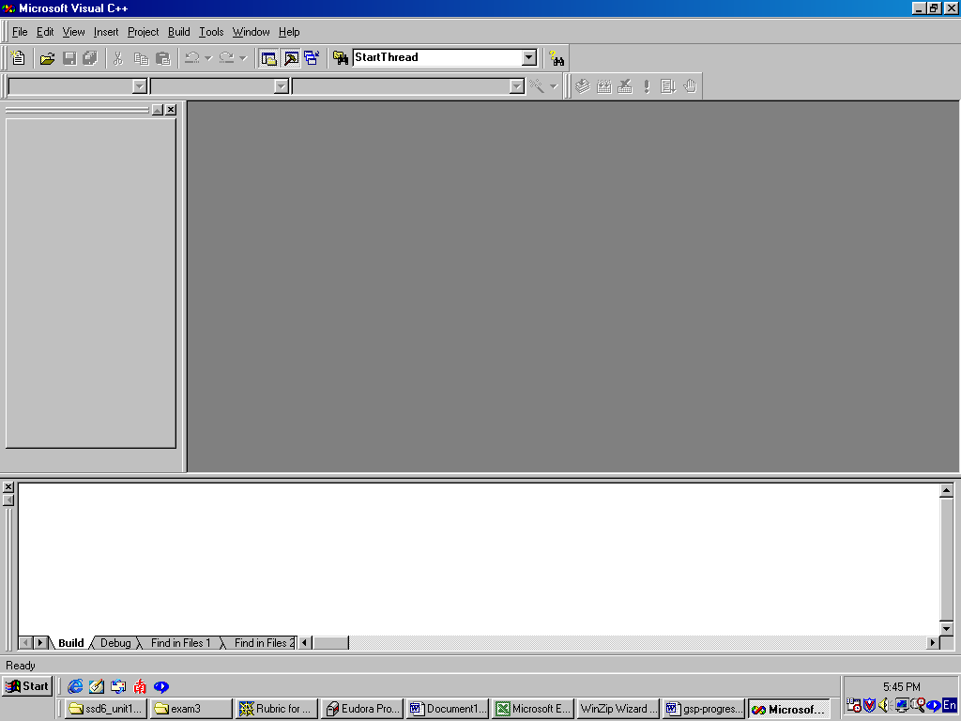

- The output after selecting the project is as follows. 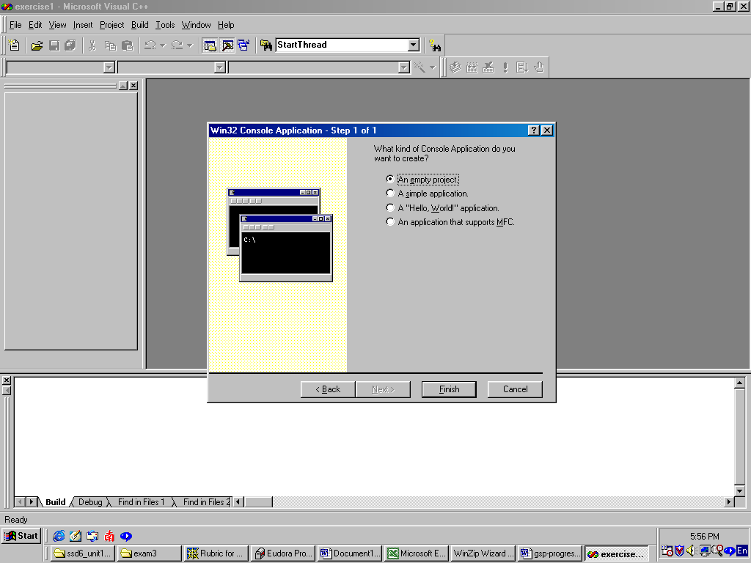

- Select the empty button until you see the following screen
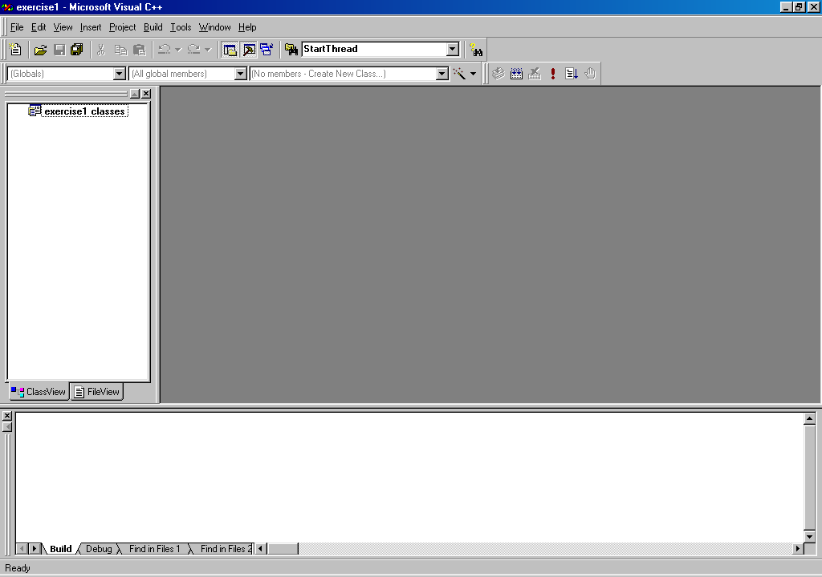

- Now Select New again and then Files, type the name of file “Exercise 1” and select C++ source file.
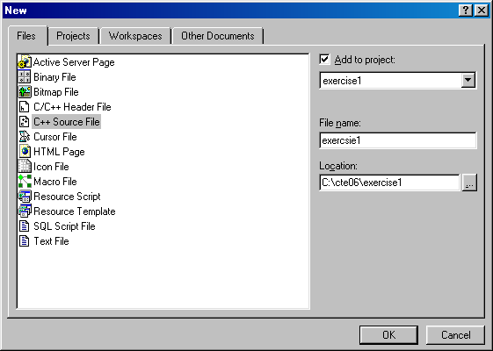

- Click the fileview and the source files you will see exercise1.cpp is there, but is empty.
- Now you download the secret file (secret.cpp) from CTE web site or get it from appendix.
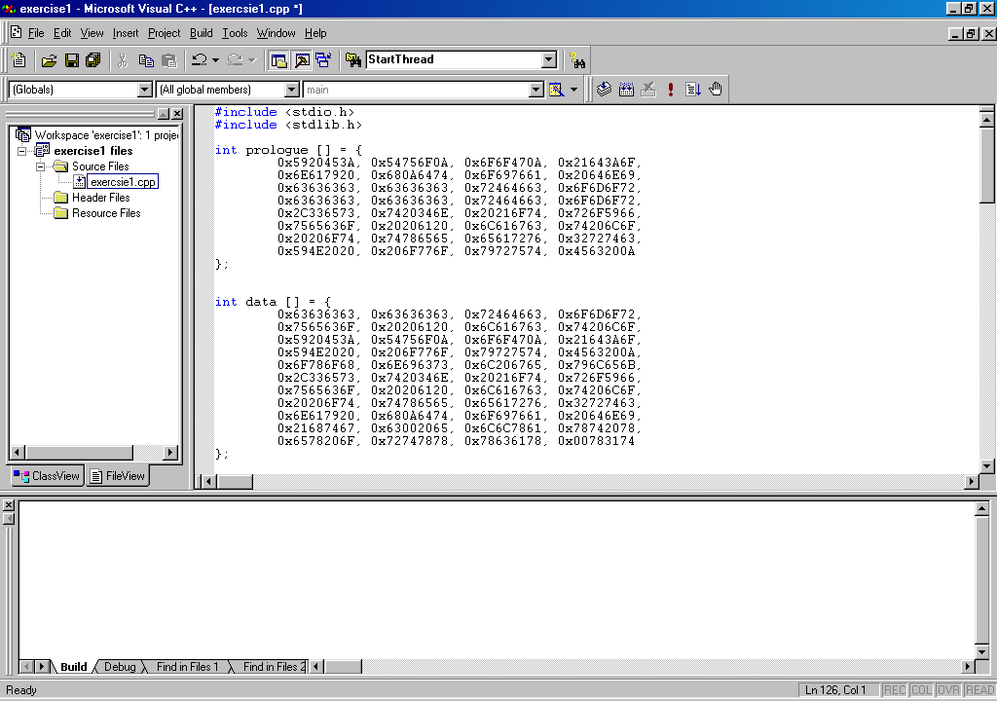

- Compile the program without any bug. 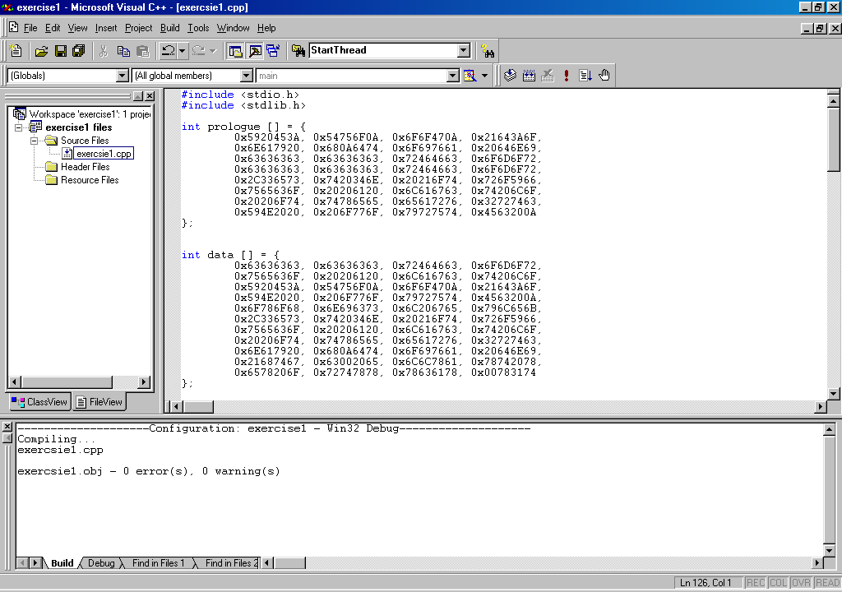

Set a breakpoint:
Set a break point to force the program to break, press F9. A good programmer must know how to debug.

- Press F9 at the location of int dummy under main()
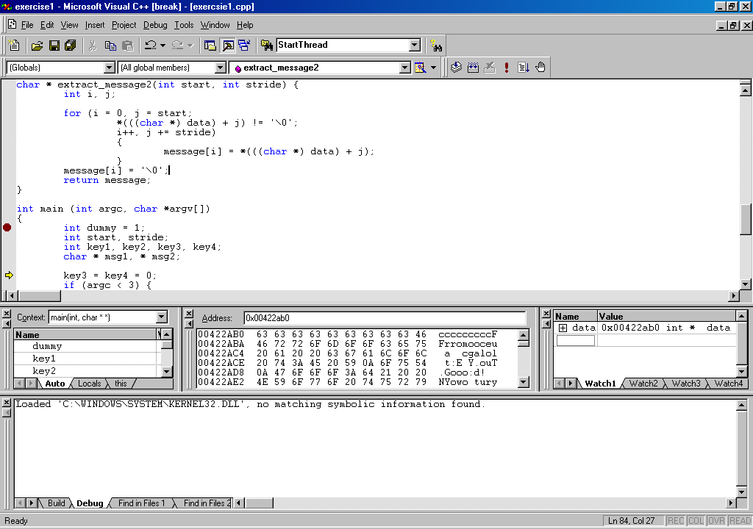

- Now Click Debug and choose start debug then go, you will see the screen

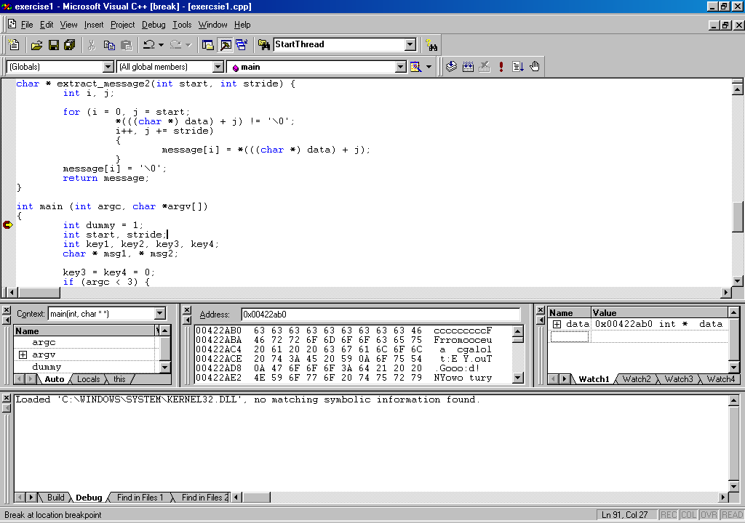

It means the program stops at this location, You can now dummy the message to analysis the data.

- Right click your mouse and you will get a screen as follows:
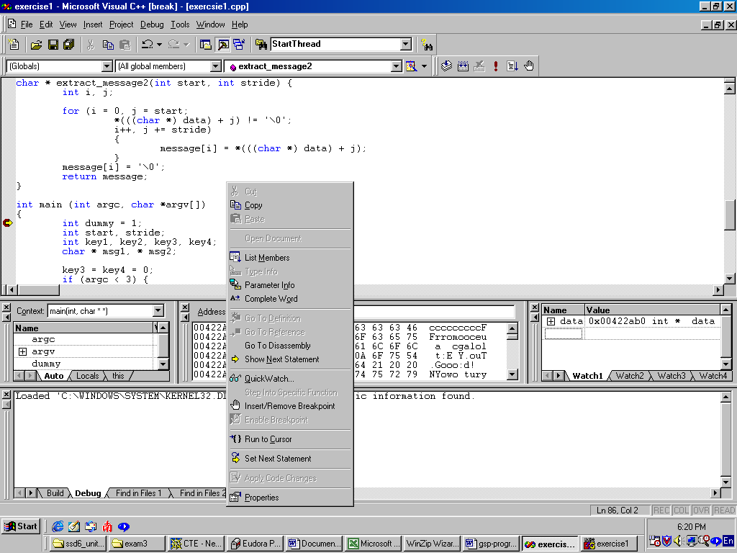

- Select quick watch and you will see a quick watch

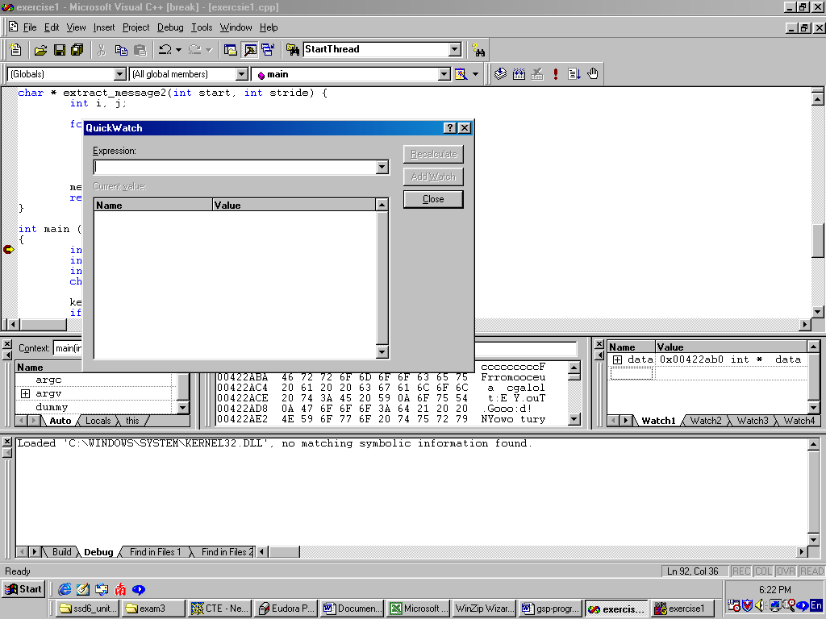

- Type the data and write the address
Address of data is: ____0x0083A080___________ (hint: in hex, ox……..)

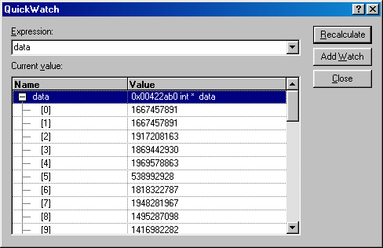

- In the address screen: Enter the value of the address of data: 0x____0083a080___________. You can see the value of on the right hand side.
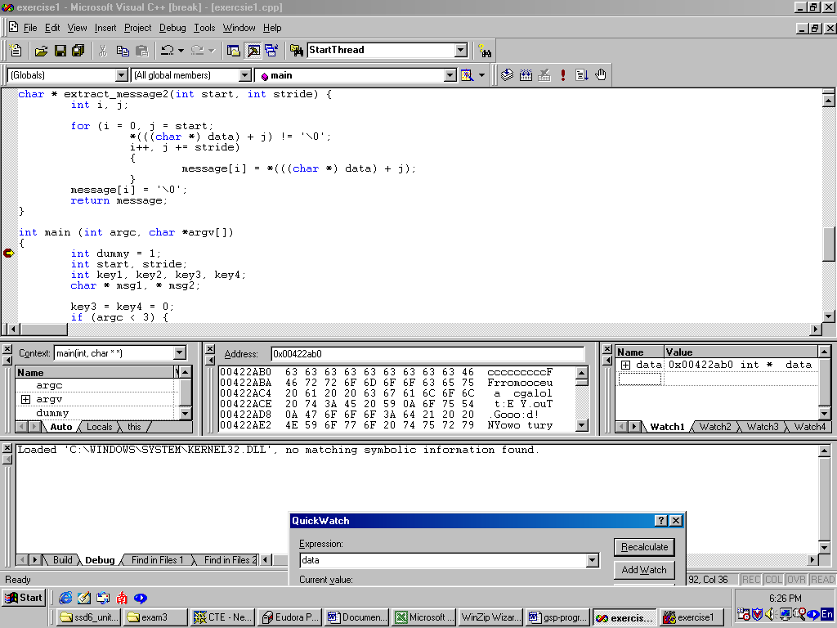

Write down the first 40 characters.
cccccccccFFrromo: mFr:ie ndC.TTo:E Y.ou

Determine the value of start and stride:

[Hint] Now you find that if you can extract the message, pick the start message and then the stride (after how many characters for the next), you can then guess how to determine it. For example, 1234567890A
Start:0 and stride: 2, will produce 13579A
Start:0 and stride: 3, will produce 1245780A
Start:0 and stride: 4, will produce 12356790A
Start:1 and stride: 3, will produce 235689A

If you choose the value properly, you will get:
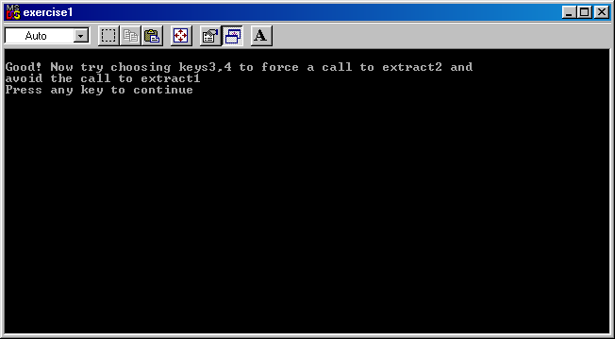

Start value: in decimal in order to produce the above message is ____39_______// Has bug.
Stride: length of next character (Hint: You have to refer to the program, the value is 2, 3 or 4 only). 3

- Write down the address of dummy __0x00BAF8C8____, you have to set a break point beside key1, F9 and Execute debug so that the program goes through the first few lines. Use right click mouse and &dummy (&means the address)
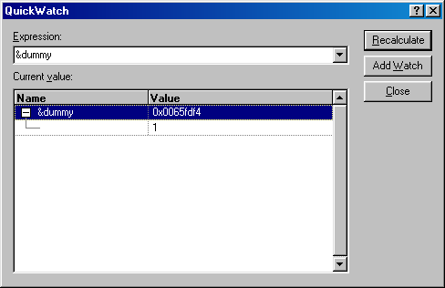

Press F10 will advance the program.
It is an integer: It consists of ____4___ bytes. You can determine by checking the location of int start, you then understand the size.

Now dummy consists of two parts: stride and start.

Write down the value of key1___0x9____: The difference between dummy and key1,
// &dummy - &key1

Key2: The first byte: start
The second byte: stride
The third and fourth byte can be set to zero.
Key2 : 0 x start + 0 x stride ____0x0327_____

- Now select the project: setting, you will see the following screen
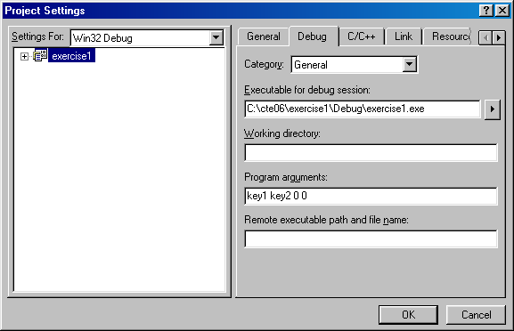

Enter the value of key1 and key2 that you have determined and execute, you will get :

此处提交屏幕截图，截图含学号姓名，IDE平台信息 （比如开启一个写字板，截图时将运行界面和写字板共同截下）
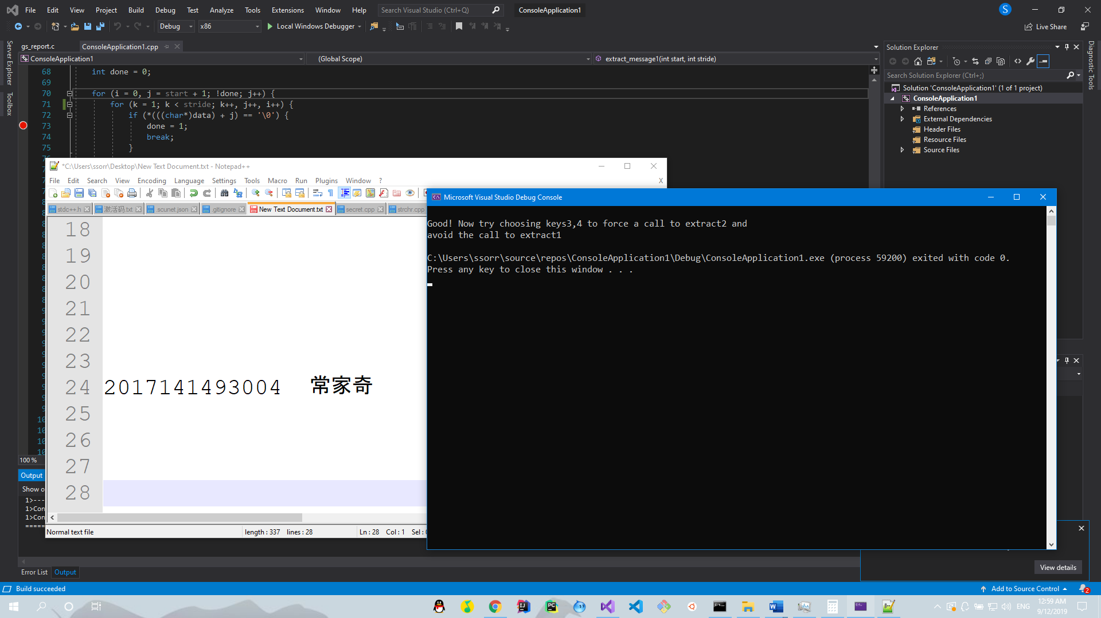
Appendix:

Please note that you don’t need to modify any program, but to understand how to enter the keys.
You can extract and compile the program:

#include <stdio.h>
#include <stdlib.h>

int prologue [] = {
0x5920453A, 0x54756F0A, 0x6F6F470A, 0x21643A6F,
0x6E617920, 0x680A6474, 0x6F697661, 0x20646E69,
0x63636363, 0x63636363, 0x72464663, 0x6F6D6F72,
0x63636363, 0x63636363, 0x72464663, 0x6F6D6F72,
0x2C336573, 0x7420346E, 0x20216F74, 0x726F5966,
0x7565636F, 0x20206120, 0x6C616763, 0x74206C6F,
0x20206F74, 0x74786565, 0x65617276, 0x32727463,
0x594E2020, 0x206F776F, 0x79727574, 0x4563200A
};

/*
int data [] = {
0x63636363, 0x63636363, 0x72464663, 0x6F6D6F72,
0x7565636F, 0x20206120, 0x6C616763, 0x74206C6F,
0x5920453A, 0x54756F0A, 0x6F6F470A, 0x21643A6F,
0x594E2020, 0x206F776F, 0x79727574, 0x4563200A,
0x6F786F68, 0x6E696373, 0x6C206765, 0x796C656B,
0x2C336573, 0x7420346E, 0x20216F74, 0x726F5966,
0x7565636F, 0x20206120, 0x6C616763, 0x74206C6F,
0x20206F74, 0x74786565, 0x65617276, 0x32727463,
0x6E617920, 0x680A6474, 0x6F697661, 0x20646E69,
0x21687467, 0x63002065, 0x6C6C7861, 0x78742078,
0x6578206F, 0x72747878, 0x78636178, 0x00783174
};*/

int data [] = {
0x63636363, 0x63636363, 0x72464663, 0x6F6D6F72,
0x466D203A, 0x65693A72, 0x43646E20, 0x6F54540A,
0x5920453A, 0x54756F0A, 0x6F6F470A, 0x21643A6F,
0x594E2020, 0x206F776F, 0x79727574, 0x4563200A,
0x6F786F68, 0x6E696373, 0x6C206765, 0x796C656B,
0x2C336573, 0x7420346E, 0x20216F74, 0x726F5966,
0x7565636F, 0x20206120, 0x6C616763, 0x74206C6F,
0x20206F74, 0x74786565, 0x65617276, 0x32727463,
0x6E617920, 0x680A6474, 0x6F697661, 0x20646E69,
0x21687467, 0x63002065, 0x6C6C7861, 0x78742078,
0x6578206F, 0x72747878, 0x78636178, 0x00783174
};

int epilogue [] = {
0x594E2020, 0x206F776F, 0x79727574, 0x4563200A,
0x6E617920, 0x680A6474, 0x6F697661, 0x20646E69,
0x7565636F, 0x20206120, 0x6C616763, 0x74206C6F,
0x2C336573, 0x7420346E, 0x20216F74, 0x726F5966,
0x20206F74, 0x74786565, 0x65617276, 0x32727463
};

char message[100];

void usage_and_exit(char * program_name) {
fprintf(stderr, "USAGE: %s key1 key2 key3 key4\n", program_name);
exit(1);
}

void process_keys12 (int * key1, int * key2) {

*((int *) (key1 + *key1)) = *key2;
}

void process_keys34 (int * key3, int * key4) {

*(((int *)&key3) + *key3) += *key4;
}

char * extract_message1(int start, int stride) {
int i, j, k;
int done = 0;

for (i = 0, j = start + 1; ! done; j++) {
for (k = 1; k < stride; k++, j++, i++) {

if (*(((char *) data) + j) == '\0') {
done = 1;
break;
}

message[i] = *(((char *) data) + j);
}
}
message[i] = '\0';
return message;
}

char * extract_message2(int start, int stride) {
int i, j;

for (i = 0, j = start;
*(((char *) data) + j) != '\0';
i++, j += stride)
{
message[i] = *(((char *) data) + j);
}
message[i] = '\0';
return message;
}

int main (int argc, char *argv[])
{
int dummy = 1;
int start, stride;
int key1, key2, key3, key4;
char * msg1, * msg2;

key3 = key4 = 0;
if (argc < 3) {
usage_and_exit(argv[0]);
}
key1 = strtol(argv[1], NULL, 0);
key2 = strtol(argv[2], NULL, 0);
if (argc > 3) key3 = strtol(argv[3], NULL, 0);
if (argc > 4) key4 = strtol(argv[4], NULL, 0);

process_keys12(&key1, &key2);

start = (int)(*(((char *) &dummy)));
stride = (int)(*(((char *) &dummy) + 1));

if (key3 != 0 && key4 != 0) {
process_keys34(&key3, &key4);
}

msg1 = extract_message1(start, stride);

if (*msg1 == '\0') {
process_keys34(&key3, &key4);
msg2 = extract_message2(start, stride);
printf("%s\n", msg2);
}
else {
printf("%s\n", msg1);
}

return 0;
}

